K2 Pathway to Settlement System Partner Portal
User Guide
Updated: April 2021
The K2 Pathway to Settlement System Partner Portal provides institutions and service provider organizations with a platform to enter and manage their programs, services, sessions, activities and events as well as the referrals that they receive post settlement assessment.
This system allows referrals to be made to the organization, program or service/activity level in a way that best leverages client strengths and needs, as well as acknowledges and respects the eligibility criteria of local service provider organizations. As this platform allows for ongoing intake of programs and activities, it provides all stakeholders with the flexibility to update their information as it changes. For frontline staff and settlement assessors and advisors, this means doing away with outdated paper flyers and binders full of partner information.
This quick reference guide provides an introduction of the K2 Pathway to Settlement System Partner Portal including which considerations partner organizations ought to consider when inputting their information to receive the most appropriate referrals. It is important to note that this system has been made with both settlement and mainstream service providers in mind and offers flexibility in inputting of information.

My Organization
The information captured under My Organization is meant to be broad and to capture general information about your organization. This will include your primary address and phone number, and the regions/parts of your host community that you serve.

Organization Information
Beyond location and primary contact details, we ask that you provide us with some more information about the services you provide funded by Immigration, Refugees and Citizenship Canada (IRCC).
*Access to IRCC-funded settlement services is facilitated and Special Focus Area (By CA Schedule 1) are for IRCC-funded organizations only
Some questions include whether you offer services for Francophone clients, women, seniors or youth as indicated in your Contract Agreement Schedule 1. Further, we will ask that you indicate which of the following services your organization provides the following IRCC-funded services: RAP, language assessment, information and orientation, employment services, language training, building community connections and whether you are a member of a Francophone association.

Service Locations
Service Locations enables us to see where your activities are taking place. We recognize that many organizations offer itinerant services, or that activities and sessions may differ from one location to the next.

New Service Location
To create a Service Location, you will need to name this site and add its full location, hours of operation and a contact person.

Programs
Programs are overarching or umbrella names for groups of Services & Activities. Programs must have, at a minimum, a 1:1 ratio with Services & Activities. That is to say, if you create a program, you must create at least one attached Service & Activity.

Examples:
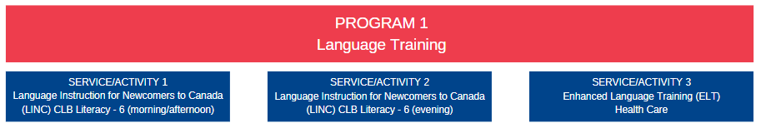
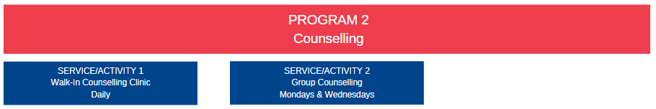

New Program
Programs are generally created and then further specified by the Services & Activities attached to them. For this reason, the information captured is quite broad. To create a program, you will need to specify the name, a description, contact person and details, languages of service offered under the program, as well as the type of funding (IRCC or non-IRCC) and one primary area of focus.
It is important to think broadly when determining an area of focus. You may offer multiple Services & Activities under one program such as Networking, Resume Building and One-on-One Career Counselling, some of which could be considered Services to increase client’s participation in communities and social networks (Community Services) but are most broadly put under Services to prepare client for the Canadian labour market (Employment related).

For programs funded by multiple parties
We are not reporting on the data captured here, rather it supports us in knowing, generally where we are referring clients.

Services & Activities
Services & Activities (SA) is the section of the Partner Portal where you input each service, session, activity or class that you host. Each SA must be attached to a Program and a single Location, meaning that you will duplicate SAs if they are offered in multiple locations.
The SA section of the Partner Portal is your opportunity to refine your eligibility criteria and tell us a little bit more about the clients for whom your services are designed.
While we work to expand our referral builder, the information that you define for Services and Activities will be made visible in the format below.
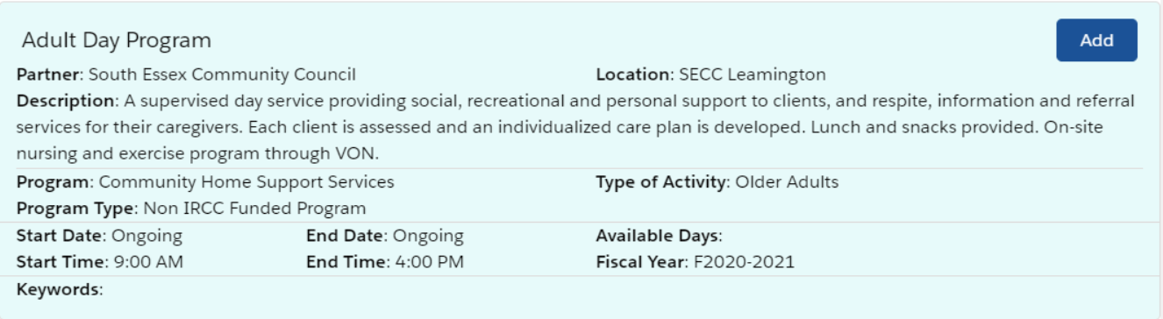

New Entry under Services & Activities
Every new entry under Services & Activities (SA) will ask you to provide a name and description, as well as the duration of the session, class, activity or service. You can choose between ongoing (April 1 – March 31) or a specific start and end date.
Further, we ask that you let us know if there are any primary client groups. The choices range from LGBTQ+ to identifying a gender for specific sessions.

Time / Days of SA
The Date and Time of the SA is for you to define, but we recognize that there are many different schedules based on each organization and the SAs they offer.
Recurring | Enter day(s) of the week and specific time  i.e.: Mondays & Wednesdays; 1:00pm-3:30pm (and Fridays 10:30am-12:00pm)
Recurring  (different times) | Enter the days only  Specify the time(s) in the description.

Keywords
You will notice that Keywords available in each SA is dependent upon the type of activity that you are entering, which is defined by the type of program it is attached to. It is important that you select all keywords that apply to the service, activity, class or session that you are inputting as it helps us to narrow down the eligibility and right services for the client assessed.

Keywords Example: Legal Information and Services
Abuse/Assault – Crisis lines for abused people
Abuse/Assault - Victims of abuse support programs
Francophones
Community Programs - Community information
Community Programs - General
Government/Legal - Community legal clinics
Government/Legal - Community legal services
Government/Legal - Consumer protection / Complaints
Government/Legal - Elected officials
Government/Legal - Human rights
Government/Legal - ID (identification)
Government/Legal - Legal information
Emergency/Crisis - Victims of crime support programs
Newcomers - Immigration / Sponsorship
Newcomers - International credentials
Newcomers - Interpretation / Translation
Newcomers - Refugees
LGBTQ+
Mental Health / Addictions - Addiction counselling
Mental Health / Addictions - In-person crisis services
Mental Health / Addictions - Justice and mental health programs
Mental Health / Addictions - Psychiatric hospitals
Mental Health / Addictions – Substance abuse

Contact Information
We request that you provide us with the contact information relevant to your service, activity, class or session here. You may simply choose to provide us with the Reception contact information.

Are there any eligibility requirements?
Min / Max Age | Please fill out if at least one field applies
Min / Max Length in Canada | Please leave blank as we work to get this field connected to our referral tool
Employment / Occupation Skills | Please leave blank as we work to get this field connected to our referral tool
Skills and Aptitude Training in Activity | Please leave blank as we work to get this field connected to our referral tool
Person with Disabilities | Please leave blank as we work to get this field connected to our referral tool
CLB Preferable | CLB refers to Canadian Language Benchmark  If you require conversational English, at a minimum, please select 4 through 12  If you require more advanced English, at a minimum, please select 6 through 12
Other Keywords | Please leave blank as we work to get this field connected to our referral tool

Are there any specific focus groups?
The only section you may choose to enter here is “Ethnic/Cultural/Linguistic Group” should this apply to your activity.

Are there any support services offered?
If you offer any type of support services, such as child care, interpretation or transportation assistance, please note so under this section. We do not ask you to elaborate on your definition of interpretation (in person, virtual, etc) or transportation assistance (taxi or bus fare, etc) as this serves only as an indicator of support that may be discussed further with clients.
Please note that these support services should be noted specific to each of the Services and Activities.

Additional Information
This is the section that lets us know what the client’s next steps ought to be. Is this service, activity, class or session by appointment only, is there a cost to participating? These questions can be answered here.

Referrals
You can see and search through your referrals here.
Under list filters, select “All” to view all listed below. By clicking on a name within your list, you will be able to see full details for that client.
One client may have multiple referrals within your organization. Click on the Referral Details for more information. Details will include basic personal and contact information, as well as Driving Statements (rationale) for referral and recommended settlement actions.
See below:
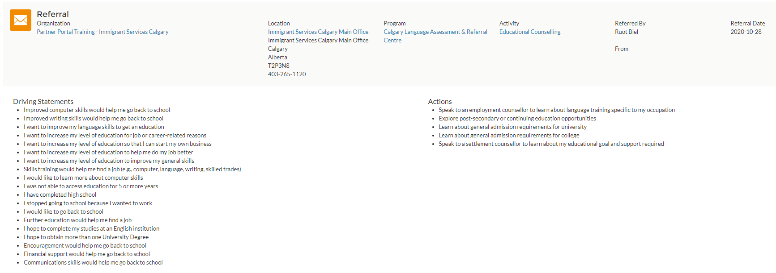
Here, you can see in the shaded area, that the key referral details are listed by which organization, location, program and activity the client was referred to, and by whom and when. Below that, you can see the driving statements (rationale) and settlement actions related to that specific referral.
Looking to send referrals to their appropriate program leads?
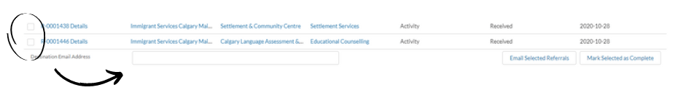
Select box(es) on the left, enter the destination email in the field below and click “Email Selected Referrals”.
Status | Definition
Received | Nothing has been done with this referral in your system as of yet, and is simply noted as received.
Distributed | You have sent this referral to someone using the “Email selected referrals” feature
Complete | You have selected the referral and clicked the “Mark selected as complete” button at the bottom right.  You may define complete for your own internal management purposes. For example, complete may confirm that you distributed the referral, or that you made initial contact with that client.

Referral List
This section allows a user to see and filter through every single referral sent to your organization.
To see all referrals your organization has ever received, click View All at the bottom right of the list.
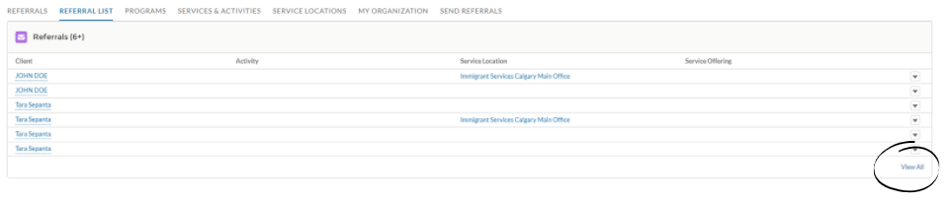
To filter the referrals, click the funnel at the top right of this full list:
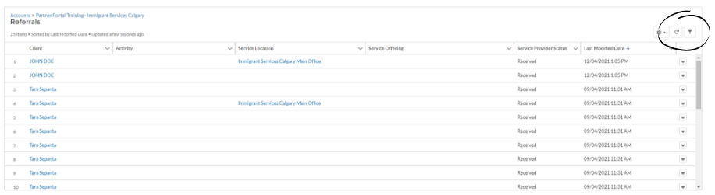
Using this feature, you can filter and sort through your referrals based on client name, and the location, service activity that they were referred to. This is particularly helpful for leaders of specific departments or programs who may want to know who the new or “received” referrals are in order to connect with these new clients.
You can also filter by status of referral, this way, you can see which referrals you have not yet sent to staff within your organization, or those not marked “complete”.

Examples

The Immigrant Education Society (TIES)*
*Information has been modified and does not accurately reflect all of their services or details
TIES is a newcomer service provider organization in Calgary, Alberta. They offer multiple programs, some of which are funded by Immigration, Refugees and Citizenship Canada, while others are not.
To help breakdown what their organization will look like in the system, let’s explore below.

Organization
TIES will add in their organization’s information, to include contact information, areas served and the types of services they offer as defined by their contract agreement with IRCC.

Location(s)
TIES has three service locations in Calgary. Each location will be added separately.

Programs / Services & Activities
Under the following chart, you can see that TIES offers Language, Employment and Job Specific Training. Some of their sessions are funded by IRCC while others are not. In total, they have created 6 programs to reflect three umbrellas/categories, each with two funders.
They then go on to add which services and activities they provide at each of the locations. You can see that they offer their services at various locations across the City, and therefore will clone and adjust their duplicated SA to reflect each location of service.
Therefore, each X below represents an individual Service & Activity entry.
Programs | Services & Activities | Location 1 | Location 2 | Location 3
English Language Training (IRCC funded) | LINC – full day | X | X | X
 | LINC – evening | X | X
 | LINC Literacy | X | X
 | LINC Home Study (Online) | X | X | X
 | LINC Blended |  | X
English Language Training (Non-IRCC funded) | Drop-In ESL | X
 | Open ESL |  | X | X
 | Literacy & Basic English | X | X | X
 | Computer Access for Literacy Learners | X | X
 | Reading Room |  | X
Employment Training (Non-IRCC funded) | Employment Skills Training (EST) | X | X | X
 | Entrepreneurship Development Training (EDT) |  | X
 | Return to Work in Alberta (ROWA) | X | X | X
Employment Training (IRCC funded) | Empowering Youth through Employment (EYE) |  | X
 | Enhancing Youth Possibilities (EYP) | X | X | X
Job Specific Training (Non-IRCC funded) | Office Administration & Computer Training | X | X
Job Specific Training (IRCC funded) | ICODE (Online) | X | X | X

Frequently Asked Questions

What about online classes?
While we are in the middle of pandemic, and many (if not all) services are being offered online, we request that you still attach these services to their respective or traditional locations but that you add “Online” to the title of your Services & Activities.
This will put us all in the better habit of being able to identify which future sessions are virtual when we return to providing services in person.

What if I have classes/sessions on odd days/times?
As an example, you may have sessions on Mondays and Wednesdays at 10:00am and Fridays at 12:00pm. In this case, do not create three separate sessions. Simply define the days of the week the sessions are held and note and the end of your Description what times are available.

What about my language classes? Do I enter each session?
No, you do not need to add every individual class. If you offer LINC 1-6, you can simply define that in your title and eligibility criteria (i.e. LINC CLB 1-6 Online).
This helps us accomplish a few things, first it minimizes the need for you to consistently update and add for each CLB. The second thing is that it allows our assessment teams to see how far their client may be able to continue studying with that organization given the CLBs that they offer.

What if my Services & Activities have multiple funders?
For the purpose of the Partner Portal, you will only be able to define Non-IRCC or IRCC funder at the program level, and not at the Services & Activities level. You may only select one, keeping in mind that we will only be referring IRCC eligible clients to your services.

What changes do you have coming in the Partner Portal?
At a high level, we will be adjusting the Services & Activities section of the Partner Portal to ensure that the information we are capturing is reflected in the Referral Builder to further inform the decisions of clients and assessment staff. This will include allowing partners to define the language of service at the Services & Activities level instead of the Program level.
We are looking to add filters that let partners define Online, Hybrid/Blended, and In-Class sessions.
We are looking to add the ability to define primary and itinerant locations under the Locations tab.
We are looking to allow partners to add multiple desired outcomes at the Program level, while further refining these details at the Services & Activity level.

What is the preferred browser?
Google Chrome is the ideal browser, but the system is compatible with Microsoft Edge and Firefox as well.

Who sees my information, and what do I get to see?
As an affiliated partner, you will get to see who was referred to you and the rationale behind those individual referrals. We will share contact information, basic information and the driving statements and actions accompanying the referral.
You will not be able to see the organization, location, program or activity information of other partners as this time, though we are exploring ways we may share this in the future. Your updated information will automatically be visible in the referral builder for assessment staff to see.

Do I get a notification when someone is referred?
No, notifications are not sent out via email or otherwise. We ask that you check into your portal on a weekly basis to support referrals as we explore email notifications.
How many accounts or logins do we receive?
Affiliated organizations receive one login at this time. You can share your login and password with those within your organization and more than one person can be working in the system at one time.

Please see below to ensure that you are using the most up-to-date version. This document will be updated on the resource page as needed.
Latest Update/Version | Changes Made
April 28, 2021 | Original Document

