NEWS RELEASE

FOR IMMEDIATE RELEASE
Thursday, August 29, 2019

BRIDGE TIMELINE TOOL SHOWCASES EMPLOYMENT & PROJECT ACTIVITIES
Users can find job postings, job guide, occupational resources, and key activities

Windsor, ON – Workforce WindsorEssex, the region’s Local Employment Planning Council (LEPC), has launched the Gordie Howe International Bridge Workforce Timeline Tool to help students, jobseekers, and the general public follow the construction progress, find employment opportunities, discover workforce initiatives, and access related occupational resources.
The new tool presents information about this bi-national infrastructure project on a timeline and aims to keep a historical record of the workforce benefits associated with hosting the construction, operation, and maintenance of the Gordie Howe International Bridge.
The menu at the top of the tool allows users to view a Key Metrics Panel, open the Bridge Jobs Board, view the Bridge Jobs Guide, or search content by keyword. When interacting with the timeline, users can zoom in and out or drag the screen side to side with their cursor. The bottom of the tool shows the entire timeline of the project and is home to a teal-coloured viewing window that shows the portion of the timeline that is being displayed on screen. The viewing window can be resized by dragging edges or by redrawing it elsewhere along the bottom.
The tool’s timeline spans 2015 to 2019, and can also include future-oriented markers such as construction goals, labour needs, career fairs, training programs, and more.
The Gordie Howe International Bridge Workforce Timeline Tool can be accessed online by visiting: www.workforcewindsoressex.com/bridge-timeline-tool.

QUOTES:
“Creating a tool like this will help us celebrate the workforce impacts that this historic project is bringing to our region, while also keeping a clear record of how the project progressed, how many workers were involved in the project, and when certain skills were needed. This information was impossible to find when Workforce WindsorEssex researched other large construction projects in 2015 because it was either secretive, forgotten, or not documented.”
- Michelle Suchiu, Executive Director, Workforce WindsorEssex
“Workforce WindsorEssex has been a highly engaged community stakeholder of the Gordie Howe International Bridge project and is a delivery partner for multiple initiatives under the Workforce Development and Participation Strategy component of the project’s Community Benefits Plan. We applaud the efforts of Workforce WindsorEssex to document one of the largest infrastructure projects in Canada.”
- Bryce Phillips, CEO, Windsor-Detroit Bridge Authority

QUICK FACTS:
- Bridging North America estimates that 2,500 jobs will be created directly by the construction, operation and maintenance of the new bridge.

- In our Bridge Jobs Guide, Workforce WindsorEssex estimated that 1,091 additional spin-off jobs will be created, including 296 jobs in retail and 198 jobs in accommodation and food services.

QUICK LINKS:
- Workforce WindsorEssex began collecting job postings related to the Gordie Howe International Bridge in October 2018 and shares them our Bridge Jobs Board.

- Workforce WindsorEssex launched the Bridge Jobs Guide on March 26, 2019 to share the list of jobs that will be created or induced during the construction, operation, and maintenance phases.

- To learn more about the Local Employment Planning Council and view our current and past projects visit www.workforcewindsoressex.com/lepc.

SCREENSHOT:
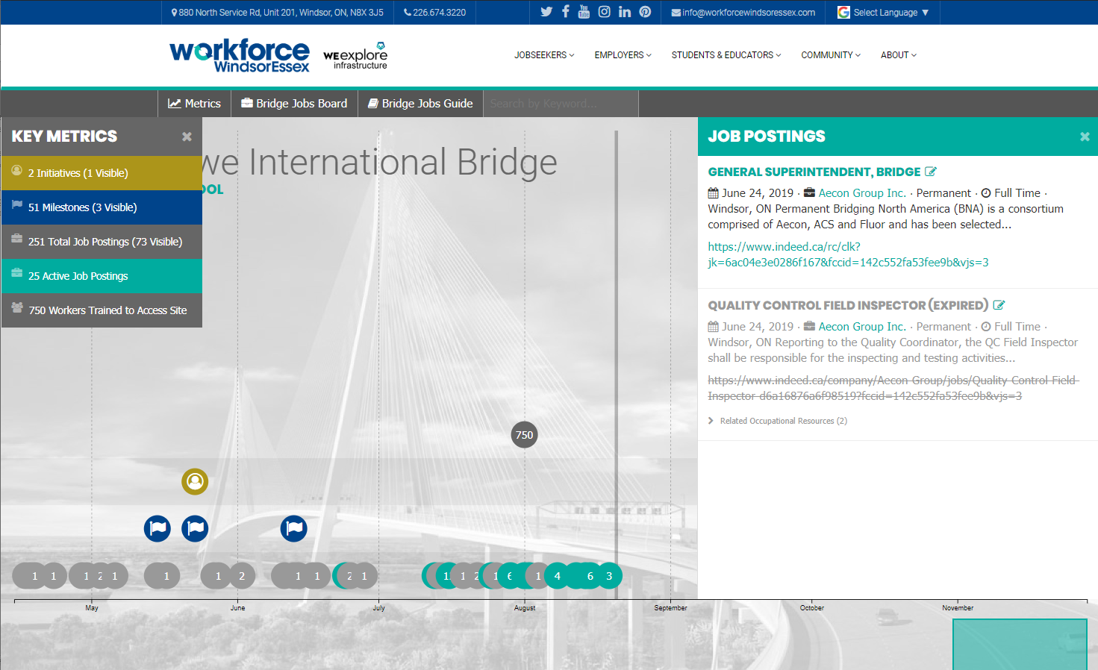

Media Contact:
Justin Falconer
Senior Director
Workforce WindsorEssex
519-980-5826
jfalconer@workforcewindsoressex.com

About Workforce WindsorEssex
Workforce WindsorEssex is a workforce and community development board that creates labour market tools, research, guides, and events that benefit jobseekers, employers, students, educators, and the community. Founded 10 years ago by the City of Windsor, County of Essex, WindsorEssex Economic Development Corporation, and the Province of Ontario, our mandate is to plan, facilitate, and advocate for regional workforce development, defined as the development, retention, and recruitment of a wide range of skilled workers to meet the current and future economic and social development needs of Windsor-Essex.
Workforce WindsorEssex currently receives funding under four projects: Windsor Essex Local Immigration Partnership, Local Employment Planning Council, WEskills, and WE Value. Learn more at www.workforcewindsoressex.com.

About the Local Employment Planning Council project
The Local Employment Planning Council (LEPC) is funded in part by the Government of Canada and the Government of Ontario. The LEPC pilot aims to increase the access to accurate, up to date, local labour market information and help pioneer new and innovative approaches to local employment planning.

