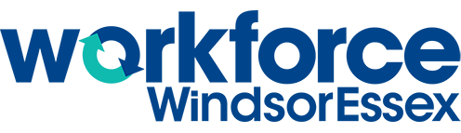
- Hard skills are the skills needed to perform a certain task (drawing, using a specific computer program, writing a business plan, etc.)
- Soft skills are the skills that make you a great employee and are important in all jobs (communication skills, time management, adaptability,taking initiative, etc.)

What Do Employers Want?
Employers are looking to hire people with excellent soft skills.
Why do you think that this is the case?
Top skills employers are looking for in Windsor-Essex:

- Computer skills
- Communication skills
- Math skills
- Design skills

Check off the following soft skills that you have:
❏ | Listening | ❏ | Cooperation | ❏ | Manners
❏ | Time Management | ❏ | Eye-contact | ❏ | Phone Etiquette
❏ | Integrity | ❏ | Speaking | ❏ | Workplace
❏ | Professionalism | ❏ | Good Attitude | ❏ | Etiquette
❏ | Motivation | ❏ | Good Attendance | ❏ | Proper Work Attire
❏ | Adaptability | ❏ | Learning | ❏ | Positivity
❏ | Reliability | ❏ | Critical Thinking | ❏ | Networking
❏ | Safety | ❏ | Problem Solving | ❏ | Accountability
❏ | Teamwork | ❏ | Creativity | ❏ | Initiative
❏ | Independence | ❏ | Planning | ❏ | Responsibility
❏ | Organization | ❏ | Punctuality | ❏ | Dependability
How can I further develop my soft skills?

How can I prove to an employer that I have fantastic soft skills?

How can I find out what kind of soft skills that an employer wants?

How does this connect to my career navigation?

