Getting Started with My Research
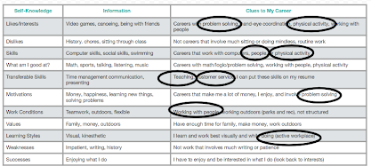
Now that you have done some general career research, it is time to make your research more personal. Look at the example below to see how Beth starts her personal career research starting from her What Does this Mean? Chart.
- Beth highlights things in her chart that keep recurring (such as working with people, problem solving, and working in a physically active career).
- Beth does the following internet searches (of course, doing at least two searches for each topic):

List of careers working with people and Careers that involve working with people Careers that use problem solving and careers for problem solvers Active careers and careers that involve physical activity

- Beth looks through the different careers listed. She writes down the ones that are interesting to her.

Now it’s your turn!
- Highlight the things in your chart that are listed many times or that you think are important.
- List at least four internet searches you will do:

