NEWS RELEASE

FOR IMMEDIATE RELEASE
Wednesday, April 17, 2019

Workforce Windsoressex Launches Region’s Largest Job Board
WEjobs board will save jobseekers time by creating a one-stop shop for jobs

Windsor, ON – With more than 2,300+ active job listings, Workforce WindsorEssex has launched the region’s largest job board called WEjobs board. This tool automatically aggregates local job postings from 14 national, provincial, and local job boards to make searching for your next job in Windsor-Essex easier than ever.
WEjobs board reduces the amount of websites that jobseekers have to visit when looking for job postings. Through this new interactive tool, you can search, sort, and filter through the region’s largest list of job postings, casting your job search net wider than ever before. One of the filter options allows users to perform quick searches for Bridge Jobs, Apprenticeship Jobs, French jobs, and upcoming Career Fairs.
Instead of trying to change employer behaviour, this tool acts as a search engine that sends users to the original job board for people to apply.
Workforce WindsorEssex is also set to publish monthly job demand reports using our own job posting data beginning May 2019 detailing interesting stats like total number of jobs posted, average posting length, top occupations posted and top hiring employers. Another report – the first of its kind to be published in Windsor-Essex – will report on who is looking for work in the region. 1st time visitors to WEjobs board, WEexplore careers, and WEmap jobs will be asked to share their gender and age grouping with us, so we can produce aggregated (and anonymous) reports on who is looking for work in our region. By participating in this research, users will help us understand how job search behaviours may differ by gender and age, and what jobs draw the most clicks. Workforce WindsorEssex will be writing a new blog series that analyzes these two reports and the other data we collect to help improve the job posting experience of employers and the job search experience of jobseekers.
The WEjobs board tool is available in more than 100 languages on our website.

QUOTES:
“WEjobs board is a great addition to our comprehensive job search tools. Like WEexplore careers and WEmap jobs before it, WEjobs board casts the biggest net possible making it the best site in the region to find local jobs. We are also excited to use the region’s largest job board to better understand who is looking for work and who is posting jobs. This research could help both employers and jobseekers better understand each other.”
- Michelle Suchiu, Executive Director, Workforce WindsorEssex

QUICK FACTS:
- WEjobs board currently aggregates job postings from 14 unique job boards including Canada’s Job Bank, Indeed, Career Arc, Jobillico, Kijiji, Charity Village, Eluta, WEtech Alliance, Lucas Works, Ziprecruiter, South Essex Community Council, Unemployed Help Centre, GECDSB Assessment Centre, and Windsor Women Working with Immigrant Women.

QUICK LINKS:

- WEjobs board can be accessed at www.workforcewindsoressex.com/jobs.

- In February 2019, Workforce WindsorEssex launched WEmap jobs, which displays local job postings, connects users to 18 related services including employment supports, childcare centres, and training, while also making planning your commute easier.

- In 2018, Workforce WindsorEssex launched WEexplore to make the process of finding, researching and applying for in-demand jobs and browsing their career paths easier than ever. It can be accessed here: www.workforcewindsoressex.com/weexplore.

- In 2017, Workforce WindsorEssex launched WEsearch to make the process of researching business funding opportunities, employment services, and upgrading programs easier than ever. It can be accessed here: www.workforcewindsoressex.com/wesearch.

- To learn more about the Local Employment Planning Council and view our current and past projects visit www.workforcewindsoressex.com/lepc

SCREENSHOT:
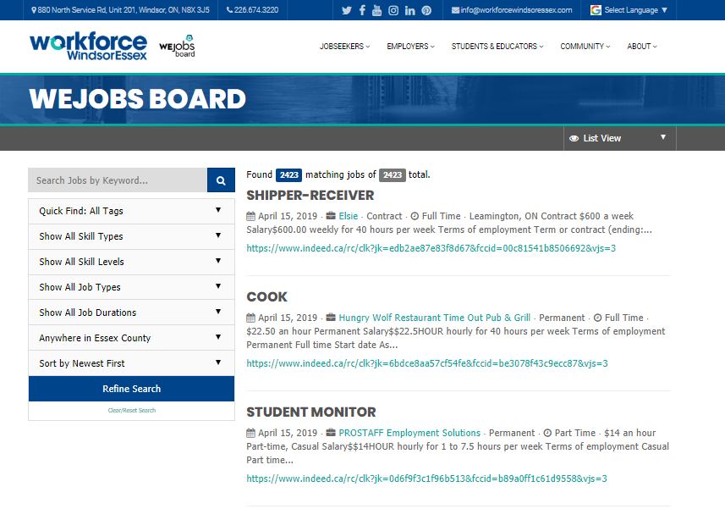
- XXX -
Media Contact:
Justin Falconer
Senior Director
Workforce WindsorEssex
519-980-5826
jfalconer@workforcewindsoressex.com

About Workforce WindsorEssex
Workforce WindsorEssex is a workforce and community development board that creates labour market tools, research, guides and events that benefit jobseekers, employers, students, educators and the community. Founded 11 years ago by the City of Windsor, County of Essex, WindsorEssex Economic Development Corporation and the Province of Ontario, our mandate is to plan, facilitate and advocate for regional workforce development, defined as the development, retention, and recruitment of a wide range of skilled workers to meet the current and future economic and social development needs of Windsor-Essex.
Workforce WindsorEssex currently receives funding under four projects: Windsor Essex Local Immigration Partnership, Local Employment Planning Council, WEskills, and WEvalue. Learn more at www.workforcewindsoressex.com.

About the Local Employment Planning Council project
The Local Employment Planning Council (LEPC) is funded in part by the Government of Canada and the Government of Ontario. The LEPC pilot aims to increase the access to accurate, up to date, local labour market information and help pioneer new and innovative approaches to local employment planning.

